27.61: a)
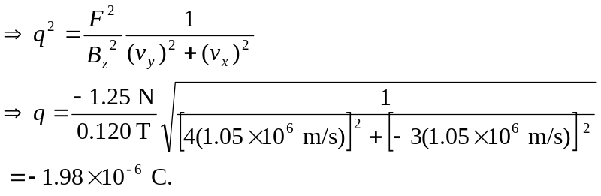

b) 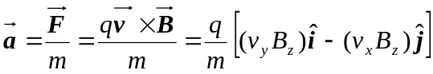
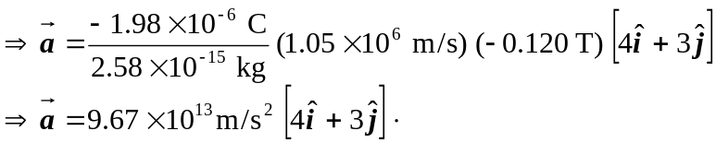

c) The motion is helical since the force is in the xy-plane but the velocity has a z-component. The radius of the circular part of the motion is:
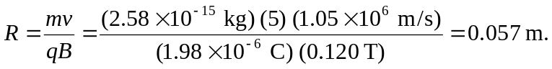

d) 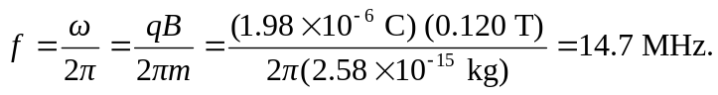

e) After two complete cycles, the x and y values are back to their original values, x = R and y = 0, but z has changed.
